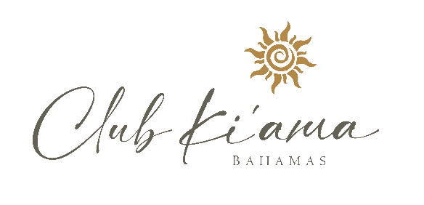

Explore The Spectacular Waters of the Exumas

Each of your magical Club Ki’ama yacht cruises is tailored to your family’s specific desires and can be from three to seven days plus in duration. The following illustrative itinerary provides an example of where a seven-day Exumas cruise might take you.

**Arrival Day**

It’s late afternoon and you are either relocating from your hotel to our yacht or being shuttled from Exumas Airport to Elizabeth Island Marina. You will be greeted by the crew upon arrival at the yacht and be familiarized with the yacht and the safety instructions. First Dinner is served on the yacht, followed by your first night aboard your floating villa.

**Day** **One**

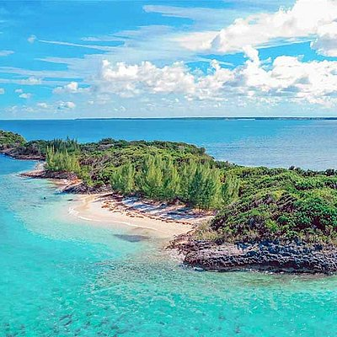

In the morning after breakfast onboard, we will lift the anchor up and sail north to Lee Stocking Island - formerly home to the Caribbean Marine Research Centre.  Following lunch, you’ll travel to Lignum Vitae Cay, one of the most stunning of the Exuma Cays, anchor off a beautiful beach for cocktails, be served dinner onboard, and then settle in for the evening.

**Day Two**

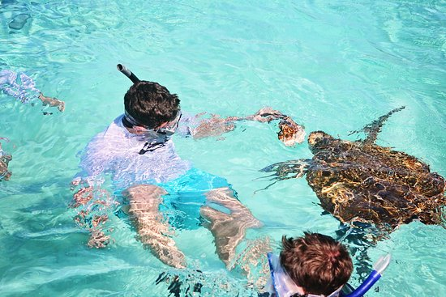

After a delicious breakfast prepared by your crew, you’ll head out for Big Galliot Cay, where you will anchor for lunch just off a beautiful beach. The snorkeling is great here, and afterwards, Talon Yacht will take you to Little Farmers Cay - where you can snorkel with turtles. Early evening cocktails will be followed by another crew-prepared dinner aboard.

**Day Three**

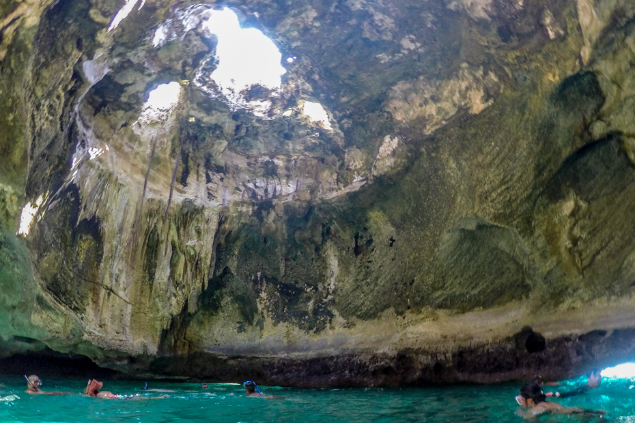

After breakfast, your crew will take you Staniel Cay, a renowned waystation for Caribbean yachters. You can experience the world-famous Thunderball Grotto, featured in the James Bond movie *Thunderball*. Snorkeling in this cave-system with its incredible marine life is mesmerizing. After your Grotto adventure, you’ll relocate to the Staniel Cay Yacht Club to take dinner ashore at Club Thunderball on your account, or aboard – your pre-determined choice.

**Day Four**

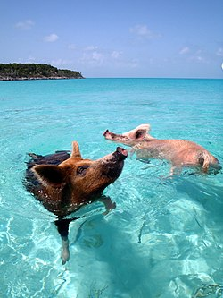

You may want to skip bacon for breakfast in case you’re quizzed by the new friends you’ll meet this morning – the world-famous swimming pigs of Big Major Cay. Apparently on perpetual vacation, they not only swim but they also drink beer. After lunch, you will silently cruise to Great Guana Cay, which is the second largest of the Exuma Cays. After working up a thirst hiking to this cay’s famous cave, you are served cocktails on the beach prior to enjoying another delicious dinner onboard your private yacht.

**Day Five**

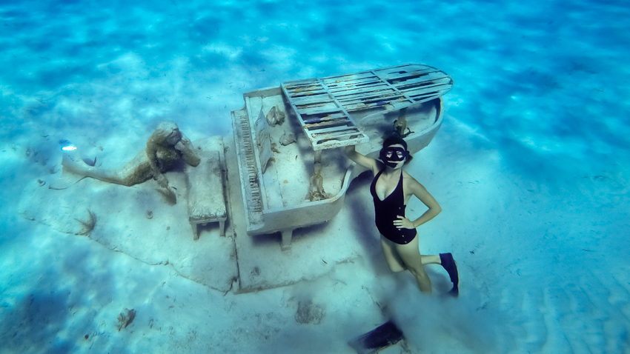

After a leisurely breakfast, the next destination is Rudder Cut Cay, which is owned by magician David Copperfield. Just off shore is a noteworthy, life-sized sculpture of a mermaid lounging atop the sandy ocean floor next to a baby grand piano – keys in the cays! After a snorkel exploration, you’ll fortify with lunch and then move on to yet another privately owned island, Leaf Cay. Here you can feed iguanas on the beach (fruit and veggies only) before your dinner on Talon Yacht.

**Day Six**

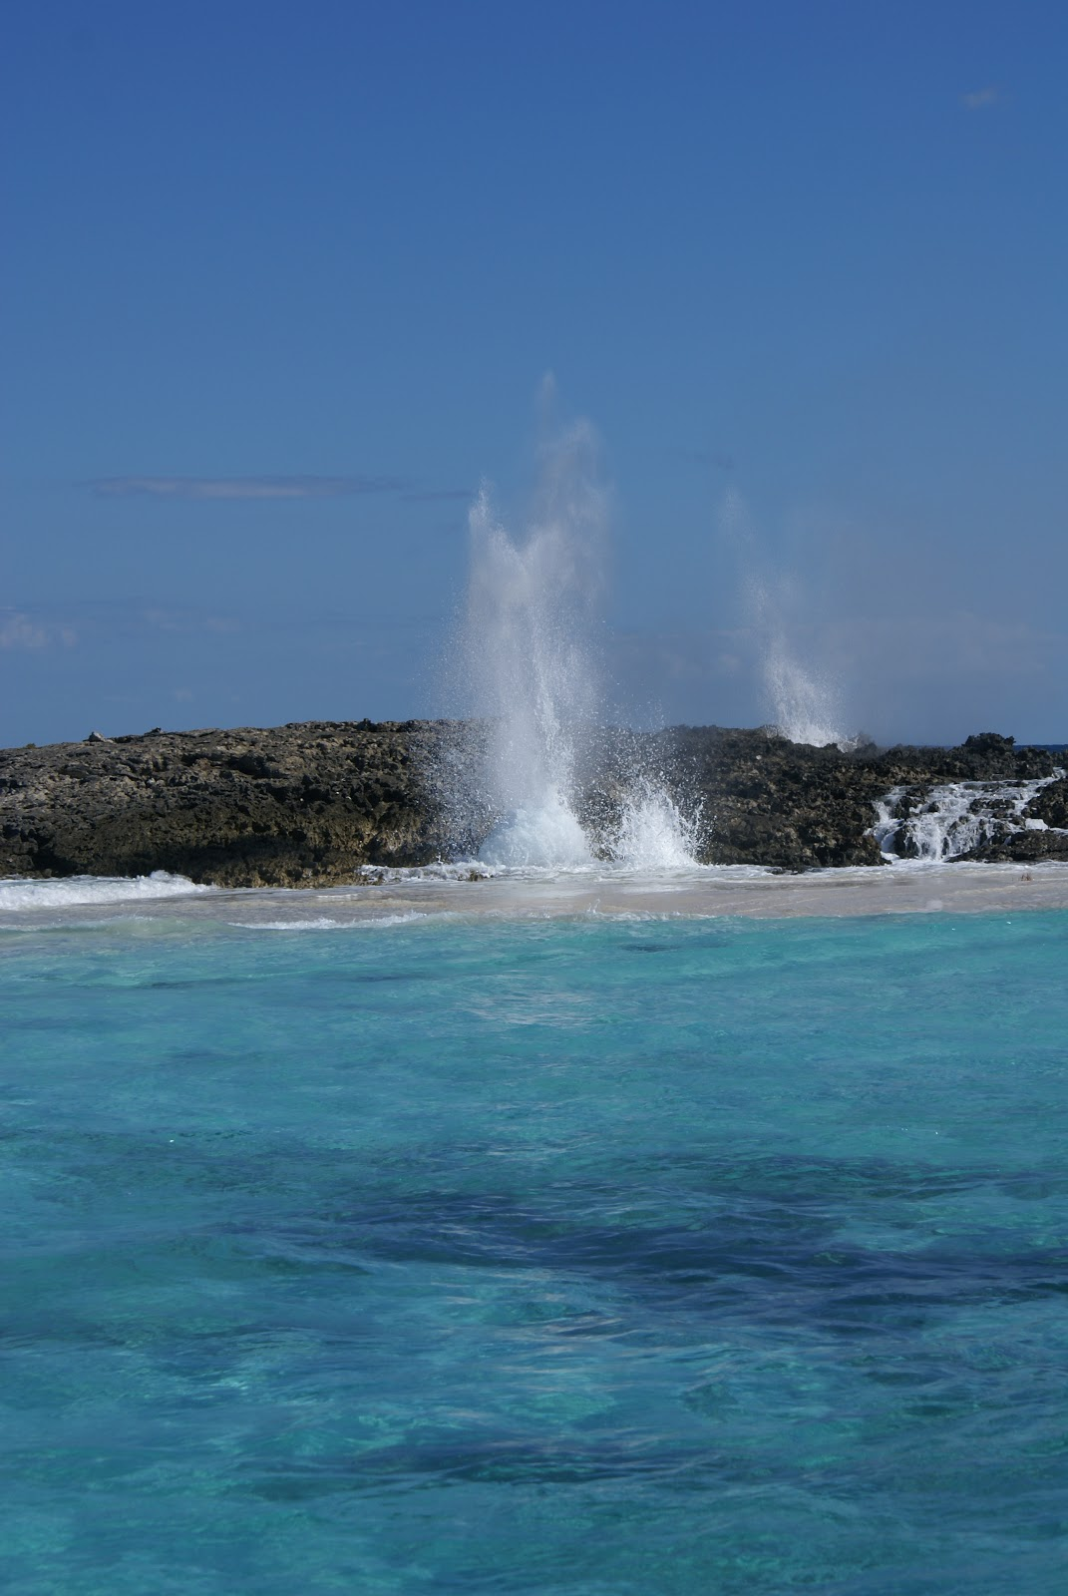

After breakfast, you will view the dramatic blowholes, cairns, beach and tidal pool of Boysie Cay. After lunch aboard you’ll sail back to Elizabeth Island, where you have your last dinner on board our Yacht.

**Day Seven - Departure Day**

After your final breakfast onboard, it's time to gather your belongings and either be shuttled by boat to George Town for your flight home or to your hotel to continue your vacation. In either case, you will depart with indelible memories and an eager anticipation of your next Club Ki’ama yacht adventure.